
SUIT participant information
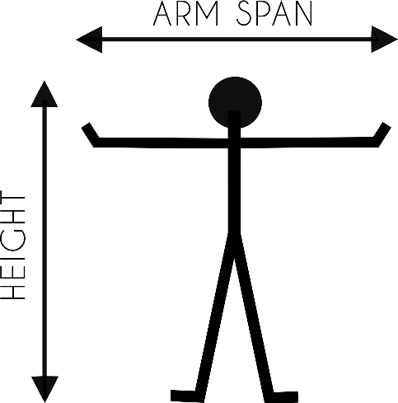
Please fill in this form to set your virtual avatar. The arm span is measured by stretching out the arms sideways. Let a colleague measure from fingertip to fingertip.

Before you put on the suit, we ask you to remove all objects made out of metal or objects that can transmit wireless data. Please ask your colleague to hold the items, such as:
- Cell phones
- Wallets
- Keys
- Radio
- Shoes with metal protection
- Watches
# | Name | Body height (cm) | Arm span (cm)
1
2
3
4
5
6
7
8
9
10
11
12
13
14
15
16
17
18
19
20

